Perran-ar-worthal

Local History Group

**Tues 24th June**

**7.30pm at the Perranwell Centre**

"Old trumperty forgotten"

The inventory of goods and chattels of Josias Pearne late of Perran-ar-worthal

Speaker: Dr Joanna Mattingley

Dr Mattingly will decipher the inventory attached to the will of Josias Pearne, late of Perranarworthal parish, who died in 1639.

The original will is held at Kresen Kernow, but a copy of the accompanying inventory was found by Geoff Ryall among the papers of his father Eric. It lists all of Josias's goods and chattels, room by room, and in the hands of a skilled historian it reveals fascinating insights into his personal and household arrangements.

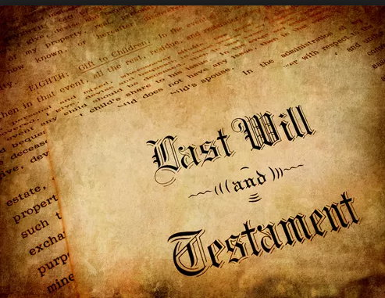

Dr Mattingley studied medieval and early modern history at London University. Her PhD was based on the Middle Thames valley, but having lived in Cornwall for over 30years, her interests have expanded to cover Cornish local history and customs. She is a bard of the Cornish Gorsedd.